**Unvegetated – Vegetated Ratio (UVVR) Geospatial Analysis**

**of Salt Marshes: Walkthrough on ArcGIS Pro**

Coastal Habitat and Restoration Team,

Jackson Estuarine Laboratory, University of New Hampshire

David Burdick (david.burdick@unh.edu) & Grant McKown (james.mckown@unh.edu)

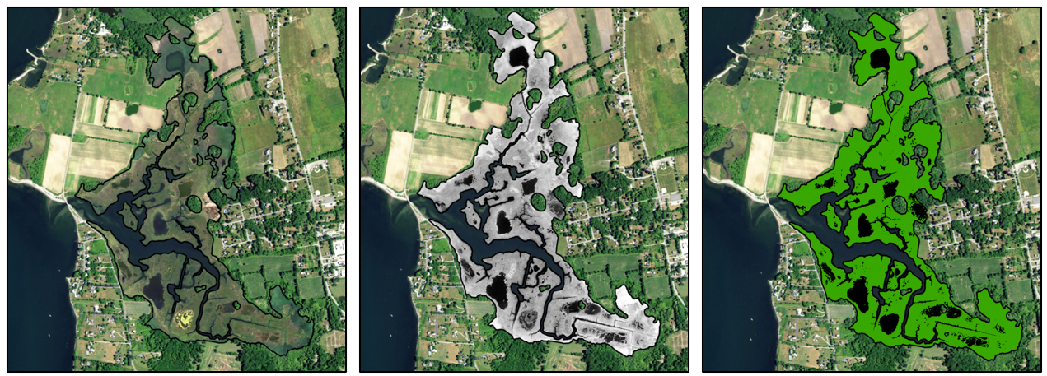

**Introduction**

One of the main restoration techniques the Coastal Habitat and Restoration Team (CHaRT) has studied and applied over the last few years is creation of runnels to drain oversaturated and drowning high marsh meadows. Degradation of high marsh meadows can take the following pathway: (1) shift of dominant vegetation from *Spartina patens* and *Distichlis spicata* to short-form *Spartina alterniflora*, (2) formation of pannes dominated by *Salicornia* sp. and bare mud, and (3) formation of permanent pools with shallow water and unconsolidated mud. Typical monitoring techniques to document restoration effectiveness include establishing transects, identifying plant species, and estimating visual cover. One of the pitfalls to the transect – plot technique is the inability to gauge the success of peat and pool drainage across the on landscape or watershed scales. Transects only cover a small percentage of the hydrologically impacted area and researchers may want to avoid disturbing the soft sediment of pools and pannes. Analysis of aerial imagery, especially over time, can provide a better understanding of the effectiveness of runnel installation across the entire drainage area. Additionally, the availability of aerial imagery over time allows for researchers to document the timing and intensity of the degradation of the high marsh meadow.

Ganju et al. 2017 outlined a new method to evaluate the degradation of salt marshes using publicly-available aerial imagery called the Unvegetated – Vegetated Ratio (UVVR). The UVVR is a unitless measurement that is the ratio of the unvegetated salt marsh surface (narrow creeks, mosquito ditches, pannes, and pools) to vegetated salt marsh surface. The UVVR ranges from zero (fully vegetated) to one (fully unvegetated). Through a large analysis of the salt marsh meadows across the east coast, Ganju et al. 2017 found that the UVVR is closely tied to a marsh’s sediment budget and long-term stability, with a possible tipping point of stability at a UVVR score of ~0.13.

The UVVR for a salt marsh can be calculated through four general steps:

1. Acquisition of aerial imagery from the National Agricultural Imagery Program
2. Calculation of the Normalized Difference Vegetated Index (NDVI) from the aerial imagery
3. Classification of pixels of the NDVI imagery into ‘vegetated’ or ‘unvegetated’
4. Calculation of unvegetated-vegetated ratio (UVVR)

Researchers most likely interested in calculating and comparing the UVVR to different sections of a salt marsh rather than for the entire marsh. For example, runnels may have been installed to only drain specific waterlogged pannes and not in pristine high marsh meadow habitats. The division of a salt marsh into tidal watersheds (‘tidesheds’) can both capture the hydrologic nature of various marsh restoration techniques (e.g., ditch remediation, runnel, and culvert expansion) and serve as treatments for monitoring studies (e.g., reference, no action, and impacted). Tidesheds are analogous to watersheds on the upland landscape, where an area drains into a common outlet. In salt marsh meadows, a tideshed is an area that drains into a dendritic creek or series of mosquito ditches. One can calculate the UVVR score for each tideshed and compare between treatments for a more accurate assessment of restoration on the vegetation community.

The purpose of this manual is to provide a detailed guide on how to calculate the UVVR for a salt marsh complex in ArcGIS Pro based on the work of Ganju et al. 2017 and Wasson et al. 2021. Their methodologies are great initial resources for those with experience in remote sensing, however, there are numerous detailed steps to fill in, especially for those familiar with ArcGIS Pro but not public aerial imagery or raster classification. The guide is written for those with basic user knowledge of ArcGIS, geospatial data sets and organization, and raster properties. Additionally, we have created a practice data set of Sapowet Marsh (Tiverton, RI) in 2016 for users to gain experience. We hope this guide will aid students, researchers, and coastal managers with their monitoring and restoration goals.

**Table of Contents**

1. **Data Acquisition & Analysis Preparation**

Step 1 – Setting map coordinate system

Step 2 – Acquisition of aerial imagery

Step 3 – Delineation of tidesheds

1. **Classification of Aerial Imagery**

Step 1 - Set up folders for the output materials of the classification and post-processing analysis

Step 2 – Classification of aerial imagery into normalized difference vegetation index (NDVI)

Step 3 – Pixel classification of NDVI into ‘vegetated’ and ‘unvegetated’ marsh surface

Step 4 – Post-classification correction of common errors

1. **Post-Classification Processing**

Step 1 – Clip the marsh surface classification to the extent of tidesheds

Step 2 – Calculate the UVVR score and percent vegetated area metrics

Step 3 – Join calculated metrics to the tidesheds

Step 4 – Export calculated metrics to Microsoft Excel

1. **Geospatial Accuracy Assessments**

Step 1 – Create accuracy points

Step 2 – Compute confusion matrix

Step 3 – Interpret the confusion matrix and classification accuracy

**Appendices:**

1. **Appendix I**: Description of remote sensing analysis for reports and publications
2. **Appendix II**: Details of shapefiles and tools in the practice data set
3. **Appendix III**: Documentation of Post Classification Analysis – Clip & UVVR Calculations Tool

Notes:

* Tools will be indicated by **bolded**.Hyperlinks are provided in the names of all ArcGIS Pro tools for users who may not be familiar or desire additional details on Esri’s website.
* The guide will be using the practice data set (see UVVR Practice File Geodatabase). All shapefiles will be indicated by ***bolded italics***. See Appendix II for additional details on individual shapefiles.
* Columns of attribute tables, coordinate systems, and XXX will be indicated by *italics*.

**Chapter 1: Data Acquisition & Analysis Preparation**

**Step 1) Set map coordinate system**

* Before we begin, we need to set up the map properly for the analysis in ArcGIS Pro. The map coordinate system is important to establish before moving forward in the analysis to ensure highly accurate calculations and raster classifications.
* Due to the smaller extent of the aerial imagery, we recommend utilizing coordinate systems that are geographically focused such as as UTM or State Planes.

Example Map Coordinate System for New England in ArcGIS Pro:

* NAD 1983 (2011) UTM Zone 19N
* NAD 1983 (2011) StatePlane New Hampshire FIPS 2800 (Meters)
* NAD 1983 (2011) StatePlane Massachusetts FIPS 2001 (Meters)
* NAD 1983 (2011) StatePlane Maine East FIPS 1801 (Meters)
* NAD 1983 (2011) StatePlane Rhode Island FIPS 3800 (Meters)
* For this tutorial, we will be measuring the UVVR score of Sapowet Marsh in Tiverton, Rhode Island. Set the Map Coordinate System to: *NAD 1983 (2011) StatePlane Rhode Island FIPS 3800 (Meters)*

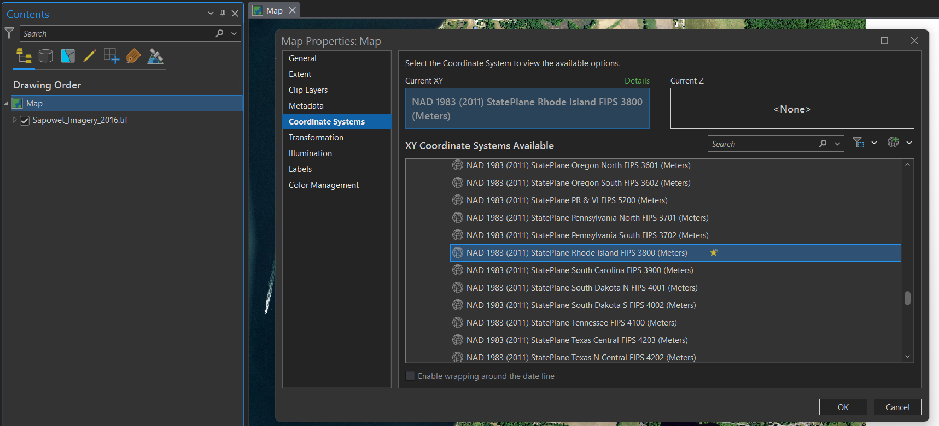

**Step 2**) **Acquisition of aerial imagery**

* The analysis requires the use of 4 Band aerial imagery (Red – Green – Blue – Infrared) to calculate the NDVI and then the marsh surface classification. Today, it is common for aerial imagery to capture the infrared band for the application of various vegetation analyses, especially by governmental and non-profit agencies.
* The National Agricultural Imagery Program, administered by the Department of Agriculture, flies individual states every 2 – 3 years. The program has been capturing aerial imagery in 4 bands since 2010 – 2012 depending on the state. Pixel resolution for the imagery ranges from 1.0 m (2010 – 2014) to 0.6 m (2016 – present) for New England states. The publicly available imagery is provided in quadrangles with file sizes ranging 100 Mb – 500 Mb. The high-resolution and availability of infrared band makes NAIP imagery perfect for remote sensing analysis of salt marsh vegetation.
* Imagery acquired from National Oceanic and Atmospheric Administration’s geodatabase repository, [Data Access Viewer](https://coast.noaa.gov/dataviewer/#/). The website is very user-friendly and is an excellent resource for accessing publicly available imagery, Lidar, and bathymetric surveys, and cover data sets across numerous federal and state agencies.
  + After opening the website, click on “Imagery” option
  + In the top right search bar, search for “Portsmouth, Rhode Island” and locate the salt marsh directly east of the bay to the salt marsh. The salt marsh is Sapowet Marsh and will be the focus on the practice guide.
  + Click the “Draw” button next to the search bar and draw a box around Sapowet Marsh
  + Numerous imagery data sets will appear including the NAIP imagery. Select the “2016 USDA NAIP 4-Band 8 Bit Imagery: Rhode Island” for the imagery of Sapowet Marsh in June 2016. If you click on the name of the data set, you will see important metadata information including pixel resolution, band details, and a link to the full metadata.
  + Click on the shopping cart icon next to the data set. Then click on the shopping cart in the top right corner.
  + Follow the directions without changing any options of the imagery data set. After submission, NOAA will email you a link to download the data set within 1 – 2 hours.
  + Once the aerial imagery has been acquired, add it to the map and zoom into the Sapowet Marsh complex

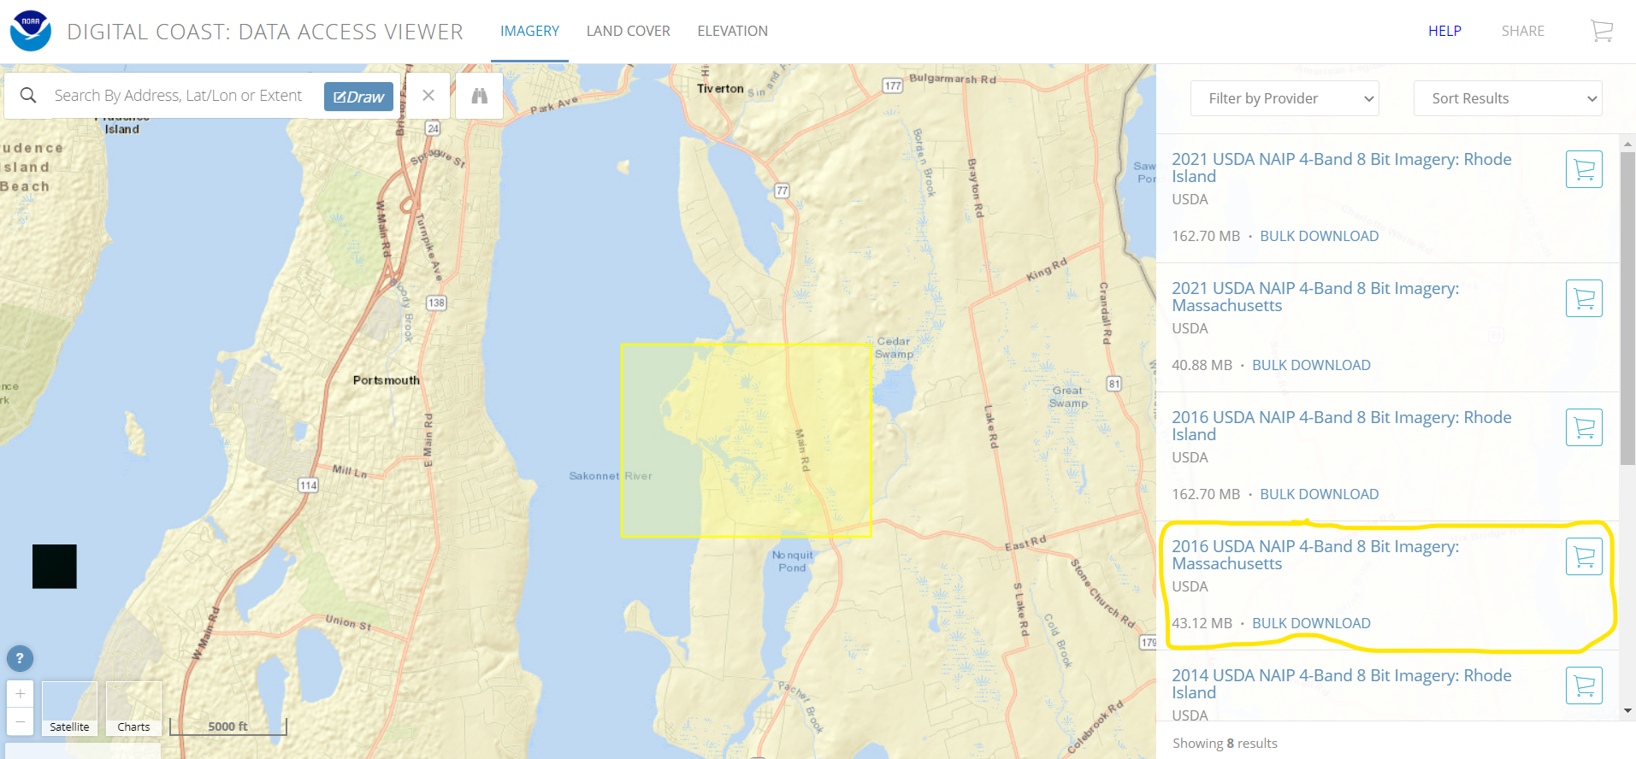

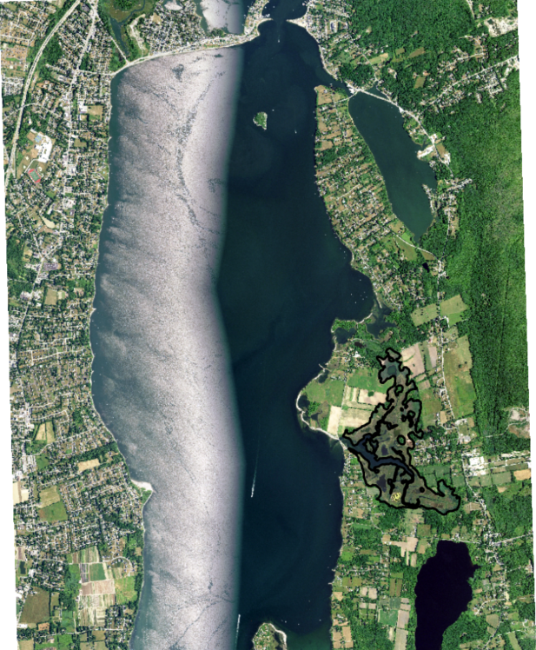

**Step 3) Delineation of Tidal Watersheds**

* Division of the salt marsh is crucial to accurately monitor the impact of restoration on the vegetation community of a salt marsh. Researchers may divide the marsh according to specific monitoring needs or for focused comparisons. For example, researchers may want to assess the utility of replanting a marsh and assess specific areas around planting zones and unplanted zones. For runnels, the purpose of this guide, the salt marsh is sectioned off into tidal watersheds or ‘tidesheds’ based on the flow of water through dendritic ditches and channels.
* Tidal watershed boundaries are primarily influenced by existing and hydrologically influential embankments, mosquito ditches, and natural creeks. For CHaRT, the approach was taken to “lump” together smaller tidal watersheds and have embankments and natural tidal creeks take precedence over small mosquito ditching. Additionally, delineation of tidal watersheds manually isolates management actions to improve surface hydrology from each other (*i.e.,* no action controls, runnels, and reference marsh).
* Ganju et al. 2017 created tidal watersheds through conventional upland watershed analysis. They utilized Lidar datasets to model stream networks within salt marsh complexes (see a more in-depth review [here](https://support.esri.com/en-us/knowledge-base/how-to-create-a-watershed-model-using-the-hydrology-too-000023169)). We found that high-resolution Lidar data sets (~ 0.5 m vertical accuracy) may not take into account the presence of embankments on the landscape (~ 20 – 30 cm in height), which are a major driver of pool and panne formation in interior marshes. Additionally, the geographic of scale of monitoring should be accounted for when delineating tidal watersheds. Ganju et al. 2017 delineated hydrologic watersheds on > 0.5 km2 scales compared to < 0.1 km2 scales to monitor restoration activities by CHaRT.
* Tidal watershed polygons are manually created by the user and should be edited and consulted with Principal Investigators who may be directing restoration techniques to improve hydrology. Typically, restoration practitioners will be interested in vegetation changes at the sub-tideshed level (< 5 acres in size).
* Tidal watersheds may be drawn manually from aerial imagery or edited from existing salt marsh boundary data. The United States Fish and Wildlife Service’s National Wetland Inventory (NWI) geospatial data is an excellent starting point for the creation of tidal watersheds. The shapefiles of the NWI can be downloaded by state at: <https://www.fws.gov/node/264847>.
  + Import the ***RI_Wetlands*** polygon shapefile into the map to show the polygons of all wetlands in the state of Rhode Island.
  + Select the wetland polygons that correspond to the Sapowet salt marsh system
  + Export the selected wetland polygons with the [**Export Data Tool**](https://pro.arcgis.com/en/pro-app/latest/help/data/geodatabases/overview/export-data.htm)to the project file geodatabase
* After the new polygons are added to the map, use the **Edit Tab** to modify the polygons into the tidesheds. We recommend doing the following:
  + Use the [**Merge Tool**](https://pro.arcgis.com/en/pro-app/latest/help/editing/merge-features-into-one-feature.htm) in the Editor tool (top of the to merge all of the salt marsh polygons together as a starting point
  + Use the [**Split Tool**](https://pro.arcgis.com/en/pro-app/latest/help/editing/split-a-feature.htm) to slowly and deliberately divide the Sapowet marsh into tidesheds

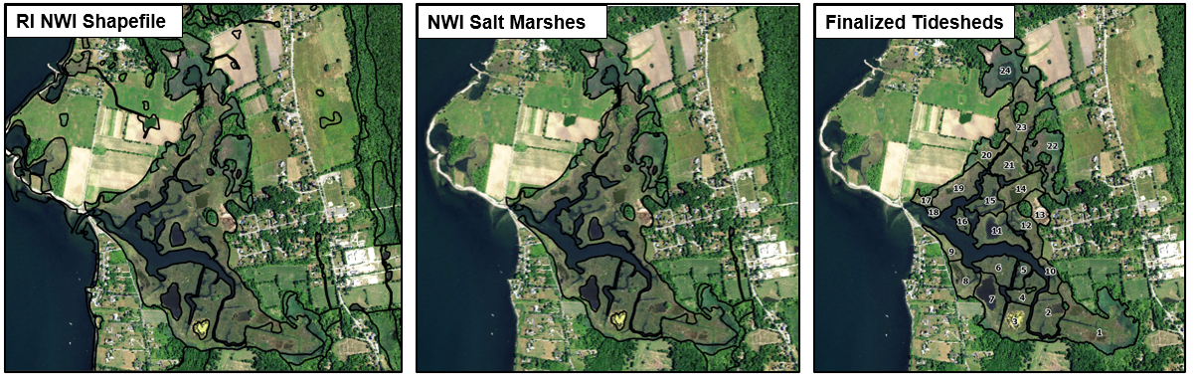

* If the user decides to create the tidesheds from scratch and delineate boundary of the salt marsh from aerial imagery manually, we recommend delineating using the earliest date in the monitoring data set. Creek widening and shoreline erosion will not be captured if the tidal watersheds are based on later years. Researchers might want to manually draw the salt marsh extent due to concerns about accuracy of the NWI data.
  + Create a new feature with the [**Create Feature Class Tool**](https://pro.arcgis.com/en/pro-app/latest/tool-reference/data-management/create-feature-class.htm)with the following inputs:
    - Geometry Type = Polygon
    - Coordinate System = Current Map [Map]
  + Using the Edit Tool Box, manually draw the extent of each tideshed based on the aerial imagery
  + When manually drawing watersheds, all natural tidal creeks and channels greater than 10 m width should be excluded, following rules set out by Ganju et al. 2017. The large tidal creeks are the natural hydrology and would not be classified as the salt marsh surface. Use the **Measure Button** in the Map Tab to quickly measure the width of channels. For tidal watersheds whose border are along small mosquito ditches or creeks (< 10 m wide), draw the borders down the middle of the creeks.
  + When manually drawing watersheds, be sure to exclude any upland islands in the site. Simply draw around the upland islands within the created tidal watershed.
* For this tutorial, we have included an example of tidesheds for use for the remainder of the practice. Import the ***Sapowet_Tidesheds*** polygon shapefile into the map.

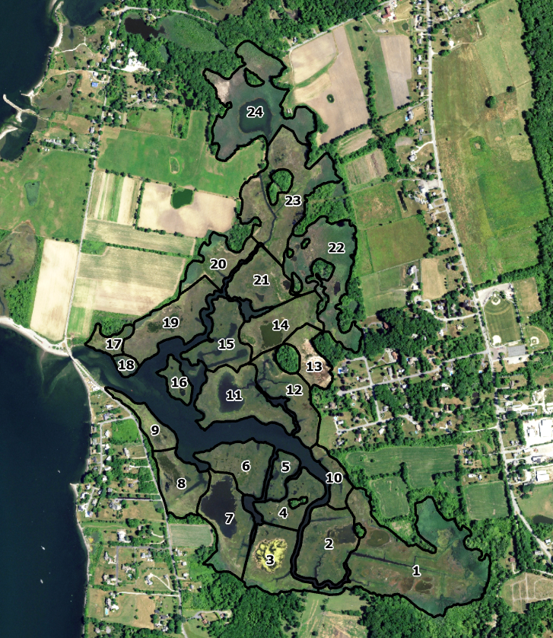

* The Sapowet Tidesheds polygon shapefile has the following columns:
  + *Tideshed* – Unique tideshed identification number; Long Type
  + *Area_ac* – Calculated area in acres; Float Type
    - Area can be calculated with the [**Calculate Geometry Attributes Tool**](https://pro.arcgis.com/en/pro-app/latest/tool-reference/data-management/calculate-geometry-attributes.htm)
  + *UVVR16* – UVVR score for 2016 aerial imagery of the tideshed; Float Type
  + *VegArea16* – Vegetated area (acres) for 2016 aerial imagery of the tideshed; Float Type

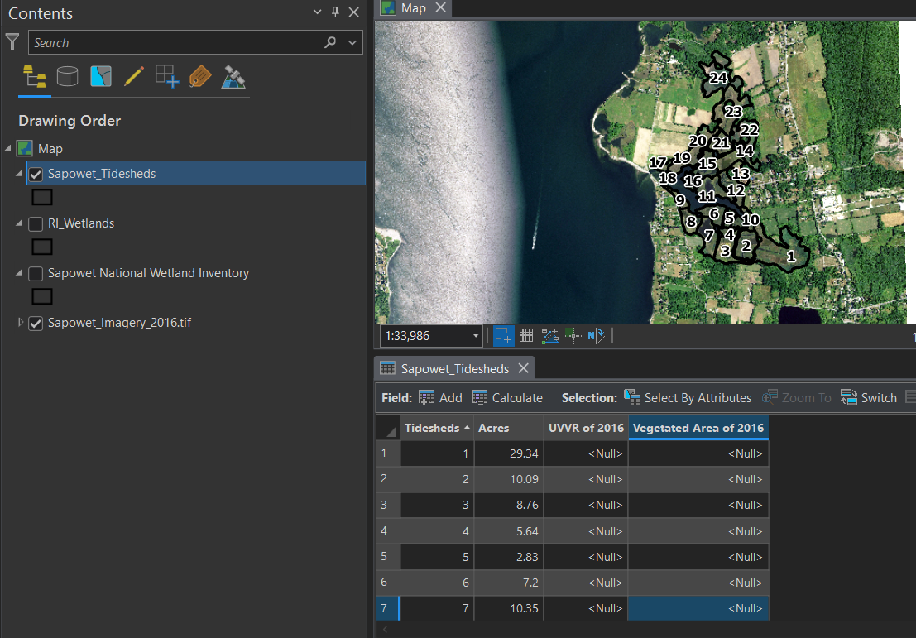

**Chapter 2: Classification of Aerial Imagery**

* The workflow for the classification of the aerial imagery takes place in 3 steps:

1. **NDVI classification** –visualize the presence and health of plants in the aerial imagery
2. **Training ArcGIS Pro** – create polygons of unvegetated and vegetated pixels from nearby salt marshes to train the program for the Sapowet Marsh
3. **Marsh Surface Classification** – classification of marsh into unvegetated and vegetated pixels

**Step 1) NDVI classification of aerial imagery**

* The Normalized Difference Vegetation Index, or NDVI, is a common measurement of vegetation health and directly monitors the photosynthetic ability of vegetation based on the “greenness” of the aerial imagery. The NDVI is frequently used to monitor the impacts of drought and wildlife on vegetation communities and the health of agricultural land during growing season. The NDVI is calculated using the Infrared Band and the Red color Band:
$$NDVI=\frac{Infrared-Red}{Infrared+Red}$$

* The index will create a new raster from the aerial imagery with the same pixel resolution and coordinate system, where white represents greater vegetation biomass and black represents no vegetation present:
  + Click on the 2016 NAIP aerial imagery in the Contents Pane
  + In the Imagery Tab, select the [**NDVI Index**](https://pro.arcgis.com/en/pro-app/latest/help/analysis/raster-functions/ndvi-function.htm) under the Index Option
    - Infrared Band = Band 4
    - Red Band = Band 1
  + The raster has not been saved onto your desktop yet. Using the **Export Data Tool** to export and save the NDVI raster for future reference.

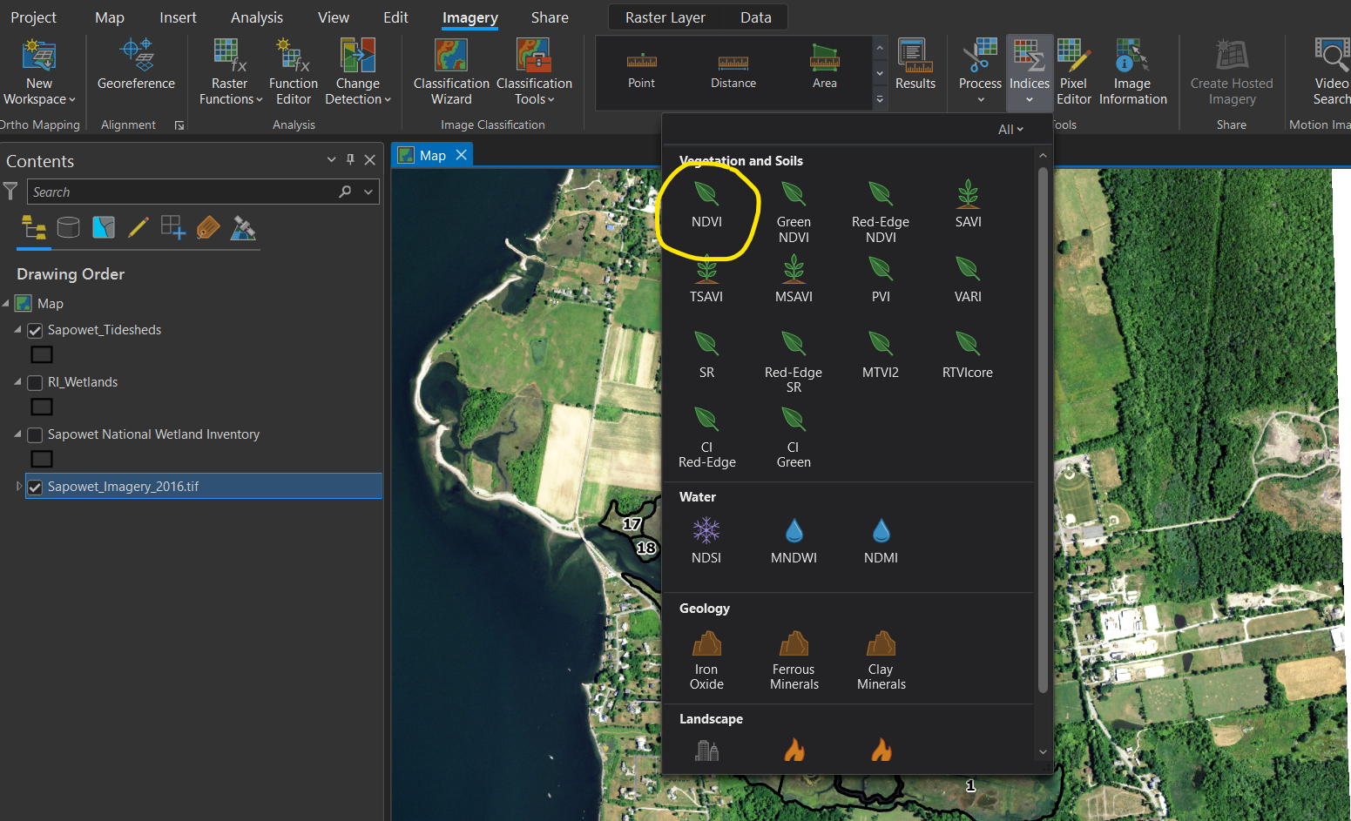

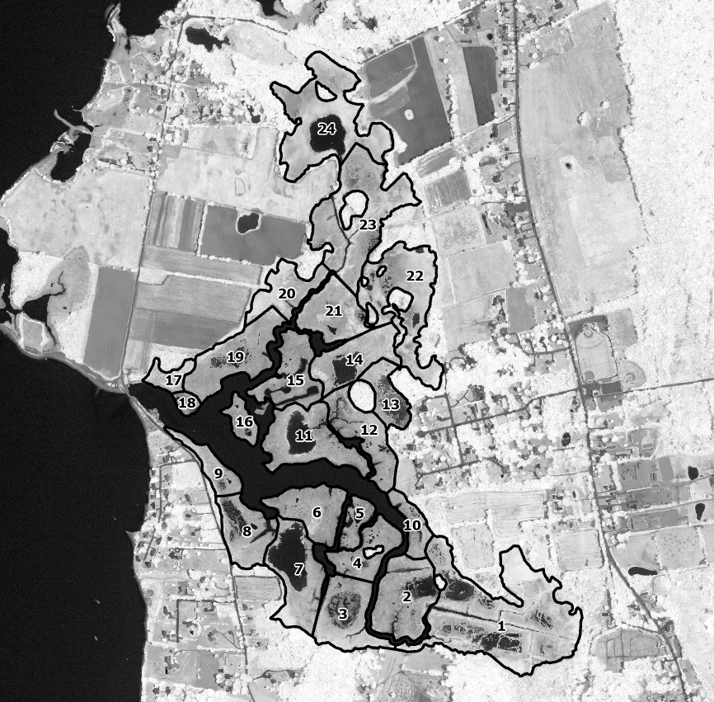

**Step 2) Create Training Polygons for Salt Marsh Classification**

* We will be completing the marsh surface classification as a **supervised, pixel-based *classification*** in the [Classification Wizard](https://pro.arcgis.com/en/pro-app/latest/help/analysis/image-analyst/the-image-classification-wizard.htm) of ArcGIS Pro. [Supervised classification](https://pro.arcgis.com/en/pro-app/latest/help/analysis/image-analyst/overview-of-image-classification.htm) is when the user actively trains the computer with examples of each category (e.g., vegetated, unvegetated). In unsupervised classifications, the computer searches for patterns in the imagery and decides to subset and classify the imagery. Pixel-based classification is when each pixel is classified into each category based on the value of the pixel (e.g., NDVI value) and ignores the values of neighboring pixels compared to object-based classification.
* We will be using a pixel-based classification methodology to adhere to the guidelines of Ganju et al. 2017. Pixel-based classification is easier to complete for those new to raster image classification. Additionally, pixel-based classification may be more suitable for identifying the emergence of pannes (e.g., small areas of water or bare space within vegetation) in degraded marshes compared to object-based classification.
* We will be applying a supervised classification methodology to have control and specifically train the program on nearby salt marshes examples of unvegetated and vegetated marsh surfaces. From experience, public aerial imagery could be captured at different times respective to growing season (July vs October) and tidal cycles (low tide vs high tide), which will require human judgement about how to train the Classification Wizard.
* To train the Classification Wizard, we will manually draw training polygons on nearby salt marshes within the 2016 NAIP aerial imagery. To remove bias from the classification, it is important to not draw training polygons on the salt marsh in question.
* First, we will create Classification Schema make the unvegetated and vegetated categories. Please note that a Classification Schema is included in the Practice Training geodatabase as *UVVR_Classification_Schema*. If you don’t want to walk through the steps, feel free to open it.
  + In Imagery Tab, Classification Tools à Training Samples Manager Button
  + Click on the **Create New Schema**
  + Left click on “Schema”, select properties, and rename to *UVVR*
  + Left click on *UVVR* and select Add New Class.
  + For the Vegetated,
    - Name = Vegetated
    - Value = 0
    - Color = Leaf Green
  + Add a new class again on UVVR. For Unvegetated,
    - Name = Unvegetated
    - Value = 1
    - Color = White
  + Save the UVVR Schema in your geodatabase as *UVVR.ecs*

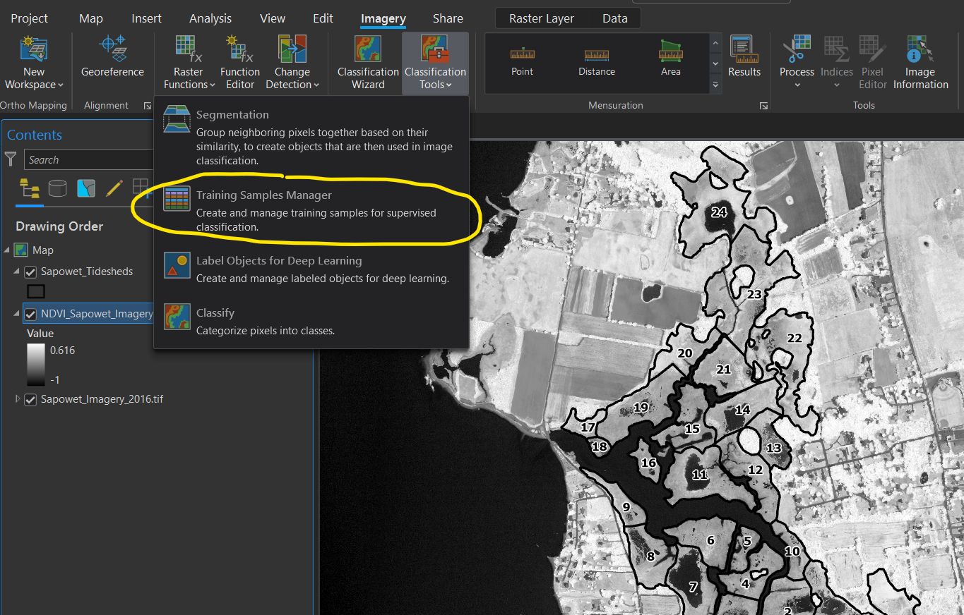

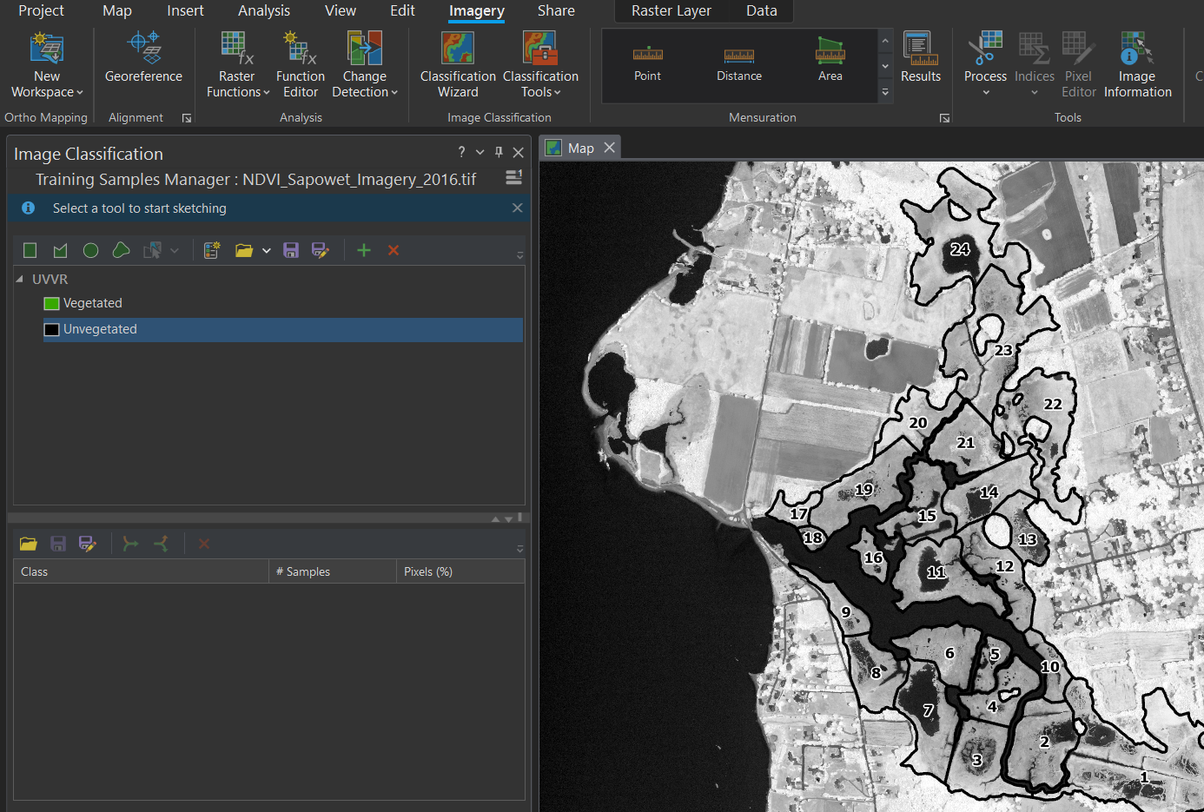

* Next, we will create training polygons for each category to train the computer of the range of NDVI values for unvegetated and vegetated marsh surface. The Training Samples Manager allows the user to easily create polygons on the aerial imagery.
* For best practices, users should create 15 – 20 polygons per classification group that spans a range of the NDVI values. For example, when drawing the training polygons of vegetated marsh surface, be sure to capture unique areas of the low marsh, high marsh, and upland edge as well as ranges of health to stressed vegetation. For the unvegetated marsh, be sure to capture unique areas of channels, interior pools, and mudflats.
* In the 2016 NAIP aerial imagery, there are nearby marshes located in the far north and south of the imagery to draw training polygons.
  + In the Training Samples Manager, click on the Vegetated schema.
  + Immediately above, click on the **Polygon Button**. This will allow you to draw free-style polygons.
  + In the north and south marshes, draw at least 15 – 20 training polygons of the vegetated marsh surface. You can draw the polygons viewing either NDVI or aerial imagery rasters. We highly recommend the user double-check with both rasters to ensure that (1) Actual vegetated marsh surface is being captured (aerial imagery) and (2) NDVI values actually represent presence of vegetation. This should be done vice versa for unvegetated marsh surface.
  + Click on the Unvegetated schema, Polygon Button, and proceed to draw 15 – 20 training polygons in the north and south marshes.
  + Save the Training Polygons for future reference
* If you make an error when drawing the training polygons, you can simply select the polygon in the bottom left-hand corner of the Training Samples Manager window and delete it.
* The UVVR Training Practice geodatabase contains training polygons labelled ***UVVR_Sapowet_Training_Polygons***

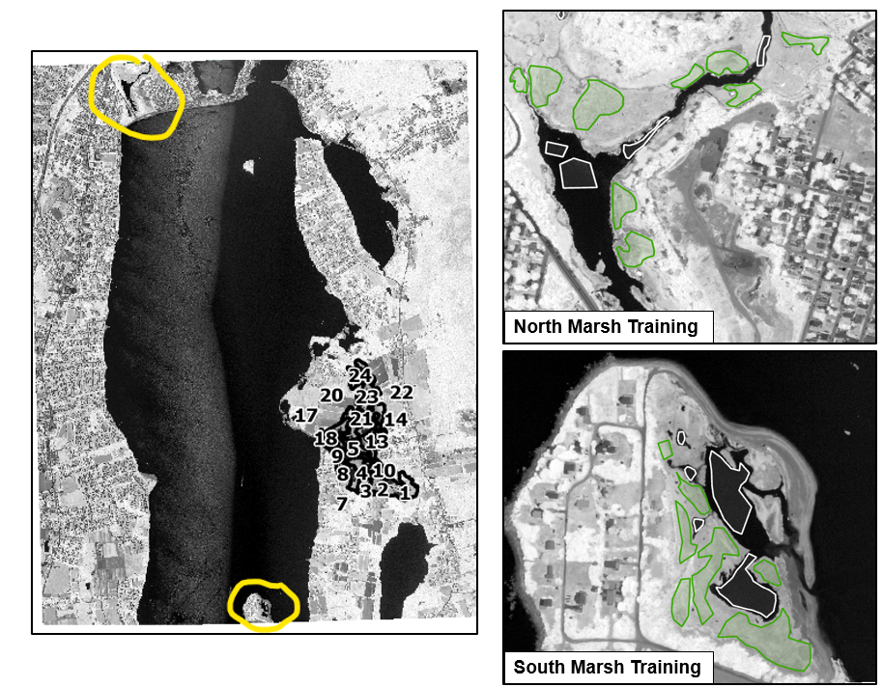

**Step 3) Classification of vegetated and unvegetated salt marsh surface**

* ArcGIS Pro makes supervised classification of image datasets incredibly easy these days with the creation of numerous tools such as the [**Classification Wizard**](https://pro.arcgis.com/en/pro-app/latest/help/analysis/image-analyst/the-image-classification-wizard.htm). We have already completed the first two main steps for image classification: (1) Creation of the input imagery data set and (2) Creation of training polygons to supervise the computer.
* It should be noted that Ganju et al. 2017 used an supervised, pixel-based classification method to classify the NAIP aerial imagery into 32 classes with [**Maximum Likelihood Classification**](https://pro.arcgis.com/en/pro-app/latest/tool-reference/spatial-analyst/maximum-likelihood-classification.htm)and then merge said classes into ‘vegetated’ and ‘unvegetated’. Wasson et al. 2021 used the NDVI as the basis for their supervised, pixel-based classification methodology. We elected to use the Classification Wizard due to (1) Ease of the classification tool, (2) Ability to quickly alter training polygons based on timing of aerial imagery collection, and (3) High accuracy of imagery classification.
* Now, let’s classify the NDVI imagery:
  + Click on the NDVI Sapowet imagery in the Contents pane
  + In the Imagery Tab, click on the **Classification Wizard Button** and fill out the following on the Configure Page:
    - Classification Method = Supervised
    - Classification Type = Pixel based
    - Classiifcation Schema = ***UVVR.ecs***
    - Output Location = Folder where you are saving all of the outputs for the tutorial
    - Training Samples = ***UVVR_Sapowet_Training_Polygons***
    - Reference Dataset = ***NDVI_Sapowet_Imagery_2016.tif***
      * Same imager we are classifying!

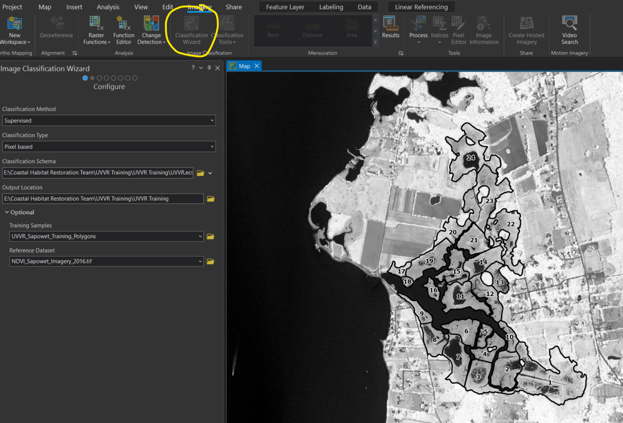

* + Click next to the Training Samples Manger window. On this page, you can alter the training samples without altering the actual polygon shapefile. Click next without changing anything.
  + On the Train window, do not change anything. We will use Support Vector Machine Classifier as our method to classify the imagery.
  + Click run and let the computer classify the imagery. Depending on your computer, this may take only several seconds or up to ten minutes. Be patient if you have an older device!
  + A new raster labelled with ***Preview_Classified*** has not been created and placed on the map. Before proceeding, let’s generally inspect the accuracy of the marsh surface classification. Click on the new raster in the Contents pane. In the Raster Layer Tab, set the Transparency to 50% and have the NAIP imagery as the background.
  + We can see that the classification worked really well for the most part! ArcGIS Pro was able to capture the vegetated marsh area, including the shoreline edge as well as delineate most of the pools. We can also see where the classification fell short – namely in shadows and floating algae in pools. If you inspect the NDVI imagery, you can see why! According to the NDVI signature, shadows look like pools and floating algae looks like salt marsh vegetation!

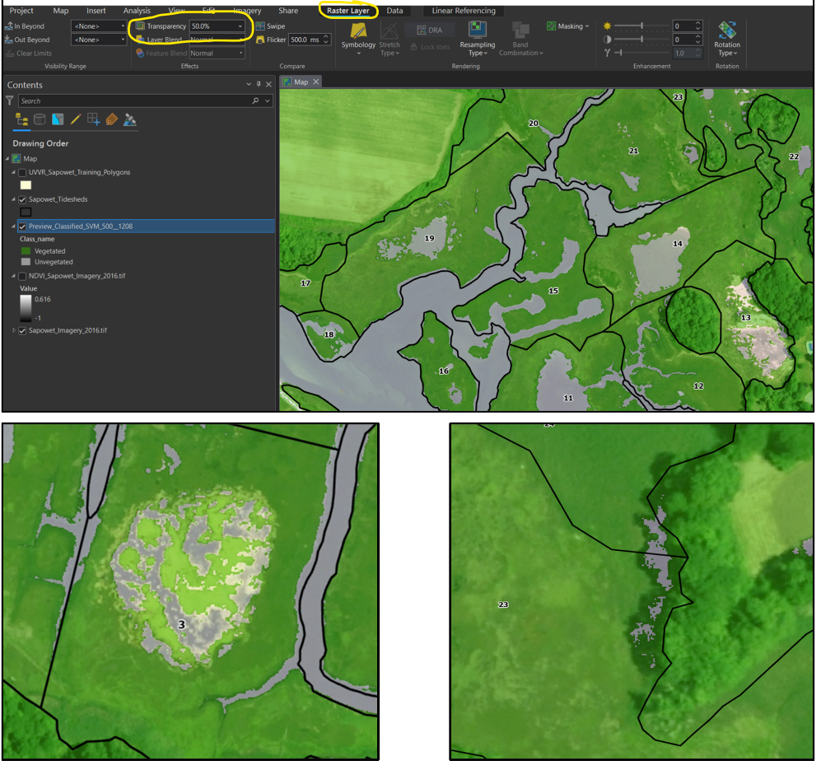

* + Once you are done inspecting the classification, go back to the Classification Wizard and click Run on the Classify window without changing anything. The computer will output a finalized classification rater. A new raster should be added to the map with the initial label of ***Classified_.*** Delete the ***Preview_Classified*** raster from the map.
  + In the Merge Classes window, click next. If you had numerous classes and wanted to aggregate them, this would be the place to do it! Another raster will be added to them with the initial label of ***Preview_SupervisedMergeClasses***. Delete this raster too from the map. Sometimes, this raster cannot be deleted until ArcGIS Pro is restarted – it is a weird quirk in the system. Just hide the visibility of the raster if you cannot delete it.
  + Lastly, export the finalized classification raster with the [**Export Raster Tool**](https://pro.arcgis.com/en/pro-app/latest/help/data/imagery/export-or-convert-raster-datasets.htm#:~:text=Right%2Dclick%20on%20the%20raster,then%20click%20Data%20%3E%20Export%20Raster.).
    - Output Raster Dataset [Name] = ***UVVR_Whole***
    - Coordinate System = Rhode Island State Plan (as the map)

**Chapter 3: Post-Classification Processing**

* At this point, we have accomplished delineating the tidal watersheds the Sapowet Marsh and have a pretty accurate classification of the salt marsh surface. For post-classification processing, we want to accomplish:

1. Clean up common classification errors,
2. Clip the NDVI and classification raster to the tidal watershed boundaries,
3. Calculate the UVVR score and Vegetated Areas for tidal watersheds, and
4. Export the results for analysis outside ArcGIS Pro

* For steps 2 – 4, a tool was created in Model Builder that quickly conducts most of the post-classification processing. The **Post Geospatial UVVR Analysis – clip & UVVR Calculations Tool** is included in the file geodatabase. See Appendix III for details and documentation.

**Step 1) Clean up common classification errors**

* The NDVI signature can be misleading for several types of cover such as floating green algae and tree shadows. The supervised classification essentially cannot differentiate between large biomasses of floating green algae and halophyte graminoids on the marsh surface, since they have comparable spectral signatures. Conversely, the presence of tree shadows can diminish the spectral signature of halophyte graminoids enough to resemble pools or mudflats.
* Due to the unavoidable nature of these classification errors, users will need to manually re-classify these areas. ArcGIS Pro has an incredibly user-friendly tool called the [**Pixel Editor**](https://pro.arcgis.com/en/pro-app/latest/help/analysis/image-analyst/pixel-editor-in-arcgis-pro.htm)to manually re-classify individual pixels and larger regions. Users should utilize multiple sources of imagery within ~ 1 year of imagery collection to confirm the extents of pools and pannes for floating green algae and the marsh surface under tree shadows. There is great imagery out there to confirm including the NAIP imagery, Google Earth, and winter leaf-out imagery from state and federal agencies. Conversion of the NAIP imagery into the [**Modified Normalized Difference Water Index**](https://pro.arcgis.com/en/pro-app/latest/help/data/imagery/indices-gallery.htm#:~:text=The%20Modified%20Normalized%20Difference%20Water,open%20water%20in%20other%20indices.) can be extremely helpful to delineating pools if imagery was collected during low tide, although it can exaggerate the extent of the pannes (waterlogged peat ≠ unvegetated marsh).
* One additional cover class that may require re-classification is temporary wrack, especially along the upland edge of marshes. Depending on the date of imagery collection, temporary wrack may be present suggesting a lack of vegetation along the upland edge, when in reality, vegetation growth may just be delayed within the growing season. This is commonly seen between April – early June in data sets. Users should use their best judgement and knowledge of the site to make this determination.
* Click on the ***UVVR_Whole*** raster in the Contents pane and change the transparency to 50% in the Raster Layer tab with the NAIP imagery as the background
  + In the Imagery tab, click on the **Pixel Editor** button. The Pixel Editor tab will be added to the far left of all the tabs.
  + In the Pixel Editor Tab, change the New Class to Unvegetated. You can change the classes at any time.
  + Next, click on the Reclassify button and select the Reclassify Region button. The Reclassify Region will allow you reclassify all pixels within manually created polygon region.
  + Go to Tideshed 3 in the south of Sapowet Marsh and locate the central pool with large amounts of floating green algae. The pool has been mis-classified due to the large biomass of algae. Trace the outline the pool to re-classify the pool to ‘unvegetated’ and double-click when finished. If you have trouble observing the pool extent in the background, increase the transparency of the classified raster.
  + Once completed, click the Save button in the right of the Pixel Editor tab to save the raster. The original raster is overwritten with the newly edited raster.
  + Search throughout the Sapowet marsh to manually-reclassify algae alage. Switch the New Class to ‘vegetated’ to address shadows.

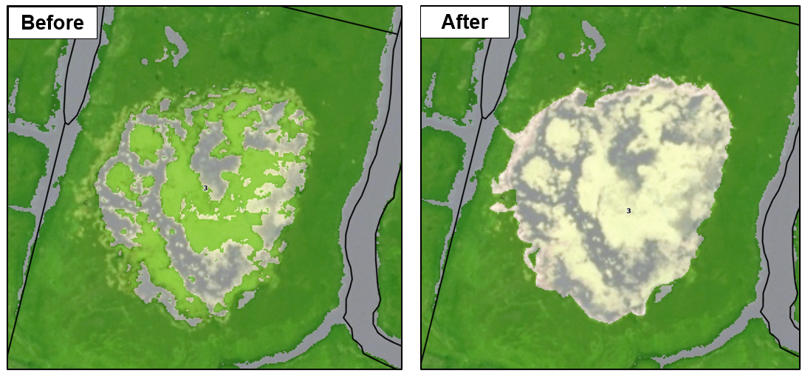

**Step 2) Clip NDVI and Classification Raster to Tidal Watershed Boundaries**

* For visualization purposes in presentations, publications, and reports, the NDVI and classification rasters should be clipped to the boundaries of the tideshed boundaries. Additionally, this will substantially reduce the file size of the rasters for distribution to stakeholders.
* Open the [**Extract By Mask** **Tool**](https://pro.arcgis.com/en/pro-app/latest/tool-reference/spatial-analyst/extract-by-mask.htm)and fill out as
  + Input Raster = ***UVVR_Whole*** or ***NDVI_Sapowet***
  + Feature Mask Data = Tidesheds Polygon
  + Output Raster = Folder with names of ***UVVR_clip*** and ***NDVI_clip***
  + In the Environments Tab, select the coordinate system the same as the map
  + Remove the whole NDVI and ***UVVR_whole*** rasters and keep the clipped rasters

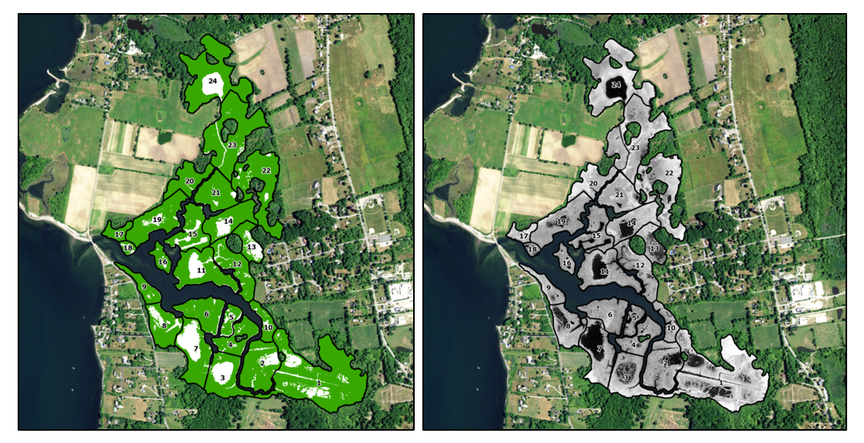

**Step 3) Calculate UVVR score and the Vegetated Area by Tidal Watershed**

* We have finally gotten to the part you have all been waiting for! Calculating the UVVR for the tidal watersheds! Essentially, we will use a few tools to calculate the metrics and then join the scores to the tideshed polygon to create a one-stop data set for export.
* For those new to working with rasters, one of the most powerful tools is the [**Tabulate Area Tool**](https://pro.arcgis.com/en/pro-app/latest/tool-reference/spatial-analyst/tabulate-area.htm), whichsums the number of pixels within specified areas including groups within a polygon feature. Another powerful tool in raster analysis is the [**Zonal Statistics Tool**](https://pro.arcgis.com/en/pro-app/latest/tool-reference/spatial-analyst/zonal-statistics.htm), which allows for a variety of calculations on the pixel values (mean, sum, standard deviation, minimum – maximum range) within specified areas.
* Open the **Tabulate Area Tool** and fill in the following
  + Input raster or feature zone data = ***Sapowet Tidesheds***
  + Zone field = *Tideshed*
  + Input Raster or feature lass data = ***UVVR_clip***
  + Class field = Value
  + Output Table = ***UVVR_table***
  + Processing cell size = 0.6
    - Processing size should always be the cell size of the NAIP imagery. The NDVI and classified rasters retain the pixel resolution of the NAIP imagery
  + In the Environments Tab, Coordinate System = Current Map [Map]
* A new table, ***UVVR_table***, has been added to the map. If you open up the attribute table of the table, you will see that for each Tideshed, the number of vegetated (Value_0) and unvegetated (Value_1) pixels has been summed.
* Next, we will add the UVVR score and vegetated area to the ***Sapowet Tideshed*** polygons to create a comprehensive data set with the [**Add Join Tool**](https://pro.arcgis.com/en/pro-app/latest/tool-reference/data-management/add-join.htm)**.** The tool connects the columns in the new table to the tideshed polygon based on a common field, which will be the *Tidesheds* column.
  + Right-click on the ***Sapowet Tidesheds*** polygon and select Joins and Relates and then Add Join.
  + Input Table = ***Sapowet Tidesheds***
  + Input Join Field = *Tideshed*
  + Join Table = ***UVVR_table***
  + Output Join Field = *Tideshed*
  + Join Fields = *Tideshed*
* Open the attribute table of the ***Sapowet Tidesheds*** polygon and you will see that the entire ***UVVR_table*** is now present. First, we will calculate the UVVR score.
  + Right click on the *UVVR of 2016* column and select calculate field.
  + Double-click the ZonalStats.Value_1
  + Single-click the division symbol ‘/’
  + Double-click the ZonalStats.Value_0
  + Click apply to calculate the UVVR Score

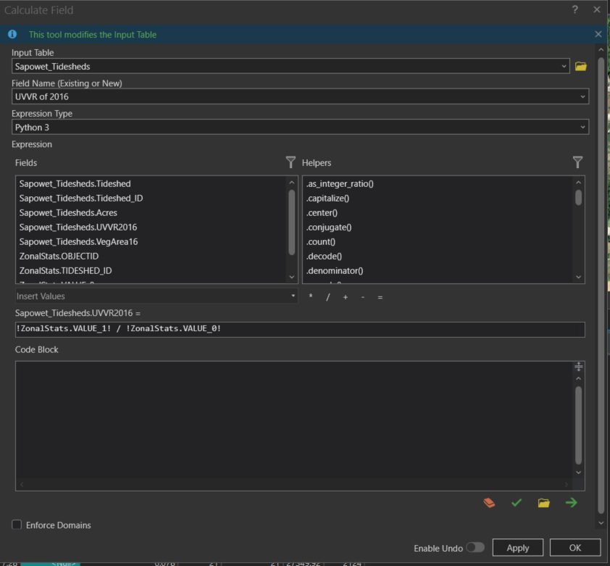

* Next, let’s calculate the area of the vegetated marsh surface for each tidal watershed
  + Right-click the *Vegetated Area of 2016* column and select Vegetated Area of 2016
  + Enter the following code into the center middle textbox:

*(!ZonalStats.Value_0! / (!ZonalStats.Value_0! + !ZonalStats.Value_1!)) * Sapowet_Tidesheds.Acres*

* + The code calculates the area of the vegetated marsh surface in acres for each tidal watershed

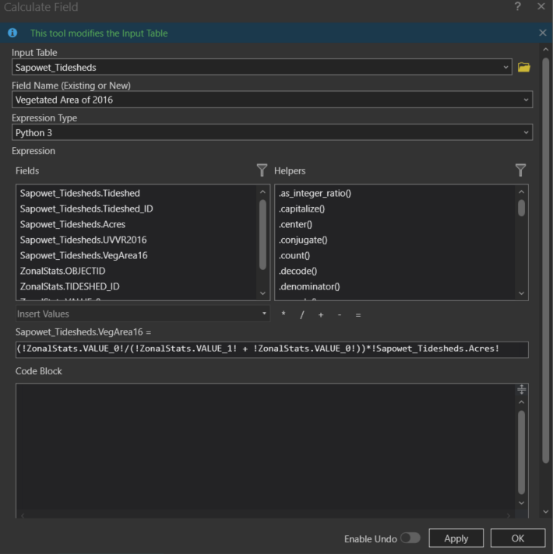

* Lastly, right-click on the ***Sapowets Tidesheds*** polygon, select Joins & Relates then Remove All Joins. This will disassociate attribute table from the polygon.

**Step 4) Export the Results for Analysis Outside ArcGIS Pro**

* Lastly, we want to export the results of the analysis to Microsoft Excel so they can be compiled in a larger data set or for analysis and visualization.
* Open the [**Table to Excel Tool**](https://pro.arcgis.com/en/pro-app/latest/tool-reference/conversion/table-to-excel.htm)and enter the following:
  + Input Table = ***Sapowet Tidesheds***
  + Output Excel File = Folder of Excel File with name of ***UVVR_Excel***
* The tool creates an .xls file of the results in a single table that can be further manipulated.

**Chapter 4: Geospatial Accuracy Assessments**

* Now that we have created a great classification of the marsh surface and calculated the UVVR scores for the tidal watersheds, we should be good, right? Almost! Before we can show off our awesome results, we need to verify that the raster classification was accurate. It is expected that accuracy assessments are conducted and reported for remote sensing analyses in scientific publications and reports. It provides a basis with how reliable a classification model is and follow-up results:

1. Create Accuracy Assessment Points
2. Ground-truth Assessment Points
3. Calculate Confusion Matrix

* Classification accuracy assessments are essentially conducted by comparing predicted values of the classification model to ground-truthed values of the real-world through a series of randomly distributed points. For this tutorial, we will conduct a randomly stratified assessment of 50 points throughout Sapowet Marsh.
* There are several options to distribute the assessments points in the marsh. We will use the **randomly stratified distribution**, where points are randomly placed in the marsh but the number of points for each group (‘vegetated’, ‘unvegetated’) are proportional to the area of the classified raster. Equalized stratified random distribution is similar but the number of points is equal across the groups. Random does not place any constraints on the number of points for each group. For additional information see [here](https://pro.arcgis.com/en/pro-app/latest/help/analysis/image-analyst/accuracy-assessment.htm).
* If the user is only conducting a limited amount of imagery classifications, it highly recommended that > 100 assessment points are distributed across the salt marsh. The greater number of points allows for a thorough investigation into the accuracy of the classification and prevents a few misclassifications from decreasing the overall accuracy substantially.
* Lastly, if users are not able to physically ground-truth the imagery, like with historic aerial imagery in this tutorial, multiple sources of imagery should be used. Degraded marshes with large extents of pannes may be difficult to assess the marsh surface from just the NAIP imagery. Additional sources of imagery may be Google Earth, Leaf-off imagery, ArcGIS basemaps, and additional imagery from USGS, NOAA, and state agencies.
* Essentially, we are going to create 50 Randomly Stratified pixels spread across our marsh site and compare Veg – Unveg classification to a ground-truth dataset to determine the accuracy of the Classification Wizard and the Training Polygons we created

**Step 1) Create Accuracy Assessment Points**

* Open the [**Create Accuracy Assessment Points Tool**](https://pro.arcgis.com/en/pro-app/latest/tool-reference/spatial-analyst/create-accuracy-assessment-points.htm)
  + Input Raster = ***UVVR_clip*** raster
  + Output Accuracy Assessment Points = save in file geodatabase with name ***Sapowet_2016_Accuracy_Points***
  + Target Field = Classified
  + Number of Random Points = 50
  + Sampling Strategy = Stratified Random
* Last note, ArcGIS may provide up to 20% more accuracy assessment points than requested when attempting to keep the number of points proportional between classes. This is totally fine!

**Step 2) Ground-truth Assessment Points**

* The accuracy assessment points have been added to the map. Open up the attribute table and you will notice three columns:

1. Point Number – identifier of each point
2. Classified – populated with 0 or 1 representing vegetated and unvegetated, respectively. This represents the predicted values from the classification model.
3. GroundTruth – populated with -1. We will manually populate each point with either a 0 or 1 based on the *actual* values based on NAIP and secondary imagery

* If the values of the *Classified* column are not 0 and 1. Open up the attribute table of the ***UVVR_clip*** raster. The *CLASSVALUE*column may have different values. Manually input 0 and 1 in the correct rows. Rerun the Create Accuracy Assessment Points.
* Hide the Classified Field so you do not cheat when creating the Ground Truth Column. Right click on the *Classified* column and select Hide.
  + Go point-by-point and determine if a point is actuallyvegetated or unvegetated by examining the NAIP aerial imagery and secondary imagery sources.
    - Right click on the row for a point and select Zoom To
    - Manually input the either 0 or 1 into the corresponding cell in the *GroundTruth* column
    - When finished, click the Save Button in the Edit Tab
  + After creating the ground truth dataset, unhidethe *Classified Column* in the Attribute Table of the accuracy assessment points. If there is a discrepancy between the *Classified* and *GroundTruth* Columns, determine what may be the cause? This may be human error or an actual error from the classification.

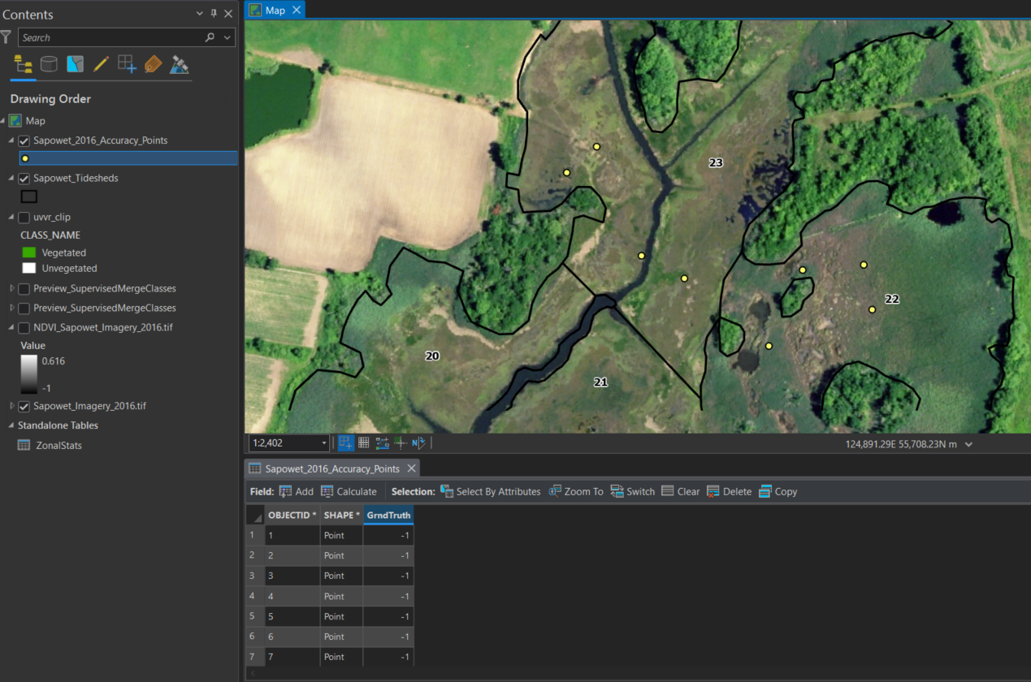

**Step 3) Compute the Confusion Matrix**

* The [Confusion Matrix](https://pro.arcgis.com/en/pro-app/latest/tool-reference/spatial-analyst/compute-confusion-matrix.htm) is the spatial accuracy assessment for the classification. The confusion matrix calculates several metrics of accuracy including User Accuracy, Producer Accuracy, and Kappa Coefficient on ranges of 0 – 100%. The user accuracy is a measure of reliability or false positives of the classification, where pixels are misclassified from the ground-truth dataset. The producer accuracy is a measure of classification accuracy from the perspective of the creator, which is the probability a pixel classified in a group is actually in that group. The kappa coefficient represents the overall accuracy of the classification model and ranges from -1 – 1. Values closer to +1 represent more accurate classifications.
$$User Accuracy=\frac{Correctly Classified Pixels in a Group}{Total Number of Classified Pixels in a Group}$$

$$Producer Accuracy=\frac{Correctly Classified Pixels in a Group}{Total Number of Actual Pixels in a Group}$$

* Open the **Compute Confusion Matrix Tool**
  + Input Accuracy Assessment Points = ***Sapowet_2016_Accuracy_Points***
  + Output = File Geodatabase with the name ***Sapowet_ConfuisonMatrix***
* The confusion matrix table will be added to the map. Open up the attribute table of the table and inspect the results of the spatial accuracy assessment. The overall Kappa Coefficient for the classification was 88.5%, which is represents a highly accurate classification! Closer inspection shows that two pixels were incorrectly classified as ‘unvegetated’. I looked located the misclassified pixels and found that the pixels were near the shoreline edge of pools. From experience, we found that the most common misclassification is along the edges of pannes and pools.

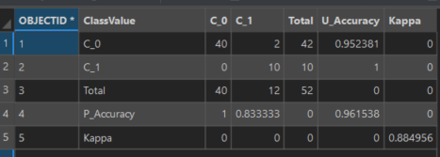

|  |  |  |  |  |  |
| --- | --- | --- | --- | --- | --- |
| **Class Value** | **Ground-truth Vegetated** | **Ground-truth Unvegetated** | **Total** | **User Accuracy** | **Kappa** |
| **Classified Vegetated** | True Vegetated Points Classified as Vegetated | True Unvegetated Points Classified as Vegetated | Total Points Classified as Vegetated | Probability Classified Vegetated Points are True Vegetated |  |
| **Classified Unvegetated** | True Vegetated Points Classified as unvegetated | True Unvegetated Points Classified as Unvegetated | Total Points Classified as Unvegetated | Probability Classified Unvegetated Points are True Vegetated |  |
| **Total** | Total True Vegetated Points | Total True Unvegetated Points | Total Accuracy Points |  |  |
| **Producer Accuracy** | Probability True Vegetated Points were classified as Vegetated | Probability True Unvegetated Points were classified as Unvegetated |  |  |  |
| **Kappa** |  |  |  |  | Overall Accuracy of Spatial Model  (Kappa Value) |

|  |  |  |
| --- | --- | --- |
| **Interpretation of Kappa Coefficient** | | |
| **Kappa Value** | **Level of Agreement** | **% Data is Reliable** |
| 0 - 0.20 | None | 0 - 4 |
| 0.21 - 0.39 | Minimal | 5 - 14 |
| 0.40 - 0.59 | Weak | 15 - 35 |
| 0.60 - 0.79 | Moderate | 35 - 63 |
| 0.80 - 0.90 | Strong | 64 - 81 |
| 0.90 - 1.0 | Almost Perfect | 82 - 100 |

**References & Additional Reading**

Congalton RG. 1991. A review of assessing the accuracy of classifications of remotely sensed data.

*Remote Sensing Environment* 37:35 – 46

Ganju NK, Z Defne, M Kirwan, S Fagherazzi, A D’Alpaos, L Carniello. 2017. Spatially integrative metrics reveal hidden vulnerability of microtidal salt marshes. *Nature Communications* 8:14156.

doi: 10.1038/ncomms14156

Kriegler FJ, Mali WA, Nalepka RF, and Richardson W. 1969. Preprocessing transformations and their effect on

multispectral recognition. *Remote Sensing of the Environment* 6:97 – 132.

McHugh ML. 20. Interrater reliability: The kappa statistic. *Biochemistry Medical* 22:276 – 282.

McKown JG, DM Burdick, GE Moore, CR Peter, AR Payen, and JL Gibson. Accepted. Runnels reverse mega-

pool expansion and improve marsh resiliency in the Great Marsh, Massachusetts (USA). *Wetlands*

Smith JAM, SC Adamowicz, GM Wilson, and I Rochlin. 2021. “Waffle” pools in ditched salt marshes:

assessment, potential causes, and management. *Wetlands Ecology and Management.* doi: 10.1007/s11273-021-09835-3

Tuxen KA, LM Schile, M Kelly, and SW Siegel. 2008. Vegetation colonization in a restoring tidal

marsh: A remote sensing approach. *Restoration Ecology* 16:313 – 323

Wasson K, NK Ganju, D Zafer, E Charlie, T Elsey-Quirk, KM Thorne, CM Greeman, G Guntenspergen, DJ Nowacki, and KB Raposa. 2019. Understanding tidal marsh trajectories: evaluation of multiple indicators of marsh persistence. *Environmental Research Letters* 14:124073. doi: 10.1088/1748-9326/ab5a94

Watson EB, F Wenley, LK Champlin, JD White, N Ernst, HA Sylla, BP Wilburn, and C Wigand. Runnels mitigate marsh drowning in microtidal salt marshes. *Frontiers in Environmental Science* 10:987246. doi: 10.3389/fenvs.2022.987246

**Appendix I: Generic Written Description for A Report or Publication**

Baseline data on marsh health before and after runnel construction was measured based on publicly available aerial imagery of the National Agriculture Imagery Program (NAIP) through the United States Department of Agriculture. Aerial imagery (RBG – Infrared) was acquired in the summer and early fall (July – October) with resolutions of 0.6 m (2016, 2018, 2021) and 1 m (2010, 2012, 2014). Tidal watersheds within each salt marsh were manually drawn based on hydrology through the delineation of existing embankments, tidal channels, and monitoring transects from site surveys. Natural tidal channels and creeks greater than 10 m in width in 2010 were excluded from the classification. The normalized difference vegetation index (NDVI) was calculated to provide a high-resolution measurement of plant health across the salt marsh surface (Wasson et al. 2019, Kriegler et al. 1969). Vegetated and non-vegetated areas (*i.e.*, water, wrack, bare mud, floating algae, and roads) were classified through the Classification Wizard Tool in ArcGIS Pro (Esri, Redlands, CA). The unvegetated-vegetated ratio (UVVR) was calculated by dividing the number of unvegetated pixels by the number of vegetated pixels within each tidal watershed (Ganju et al. 2017). Spatial accuracy assessments were conducted for every year of each site based on 50 stratified random points (Congalton 1991 McHugh 2012). Points were visually ground-truthed based on NAIP, Google Earth imagery, and Leaf-off imagery from state agencies.

**Appendix II: Details of Shapefiles and Tools in Practice Dataset**

A folder, file geodatabase, and toolbox were created to compliment and strengthen the tutorial for any user by providing examples of each step. The shapefiles and rasters have brief accompanying metadata describing. All shapefiles, tables, and rasters created in the tutorial are provided except for the NAIP aerial imagery on account of the file size. Rasters and classification schema are located in the folder, shapefiles and tables in the file geodatabase, and tool in the toolbox.

**Rasters & Classification Schema:**

1. **UVVR_Clip** – the final classification raster of the marsh surface clipped to the boundaries of the Sapowet Marsh tidesheds.
2. **NDVI_Clip** – the normalized difference vegetation index (NDVI) raster of the 2016 NAIP imagery and clipped to the boundaries of the Sapowet Marsh tidesheds.
3. **UVVR.esc** – the classification schema of ‘Vegetated’ and ‘Unvegetated’ for the Training Manager and Classification Wizard components of the tutorial.

**Shapefiles and Tables:**

1. **Sapowet NWI** – the polygons of all wetlands documented by the National Wetland Inventory of the US Fish and Wildlife Service within the boundaries of the Sapowet Marsh tidesheds. The wetlands range from mudflats to salt marshes to freshwater wetlands.
2. **Sapowet Tidesheds** – manually delineated tidesheds of the Sapowet Marsh based on the 2010 NAIP imagery. The shapefile has the area (acres), UVVR score of 2016, and vegetated area of 2016 calculated from the tutorial in the “finalized” shapefile and left black in the “tutorial” shapefile.
3. **Sapowet Training Polygons –** training polygons created from the tutorial of the northern and southern marshes visible in the 2016 NAIP imagery. The training polygons are grouped as ‘Vegetated’ and ‘Unvegetated’ and can be immediately used in the Classification Wizard.
4. **Sapowet Accuracy Points** – randomly stratified spatial accuracy points with fully completed ground-truth column from 2016 NAIP and Google Earth imagery. The points can be immediately used to calculate a confusion matrix.
5. **Zonal Statistics –** the summation of ‘vegetated’ and ‘unvegetated’ pixels within each tideshed of Sapowet Marsh post-classification.
6. **Sapowet Confusion Matrix** – the calculated confusion matrix for the spatial accuracy assessment based on the Sapowet Accuracy Points.

**Tools:**

1. **Post Classification Analysis – Clip & UVVR** – a tool to speed up the post-classification process by performing the following tasks: (1) clip the marsh surface classification raster to the tideshed boundary, (2) tabulate by area the pixels by each tidal watershed, (3) calculate the UVVR score for each tidal watershed, (4) export the tabulate area and UVVR score table to Microsoft Excel, and (5) join the tabulate area table to the tideshed polygons by tideshed identification number. See Appendix III for more details.

**Appendix III: Documentation of Post Geospatial UVVR Analysis – Clip & UVVR Calculations Tool**

We created a tool through the Model Builder of ArcGIS Pro to speed up tasks post-classification of the salt marsh surface. Specifically, the tool completes the following tasks:

1. Clips the marsh surface classification raster to the tideshed boundary,
2. Tabulates by area the pixels by each tidal watershed,
3. Calculates the UVVR score for each tidal watershed,
4. Exports the tabulate area and UVVR score table to Microsoft Excel, and
5. Joins the tabulate area table to the tideshed polygons according to tideshed identification.

After the tool is completed, the user only needs to perform a few minor tasks to finalize the post-classification steps outlined in Chapter 3 of the tutorial. Specifically, the user needs to add the UVVR score and calculate the vegetated area in the attribute table of the tideshed polygon. The tool completes the tasks within ~1 minute compared to 5 – 10 minutes of manually completing each tool individually. The tool does not contain any tool or feature that was not covered in Chapter 3 of the tutorial.

**Inputs of Tool:**

Tideshed Boundary = Tidal watershed boundary polygon ***(Sapowet_Tidesheds)***

Classified Vegetation Marsh Raster = Finalized classified raster of the NAIP imagery ***(UVVR_whole)***

Destination of Clipped Vegetation Raster = Folder and name of clipped vegetation raster (***Sapowet_clip)***

Destination of Tabulated UVVR Table = File geodatabase and name of table (***ZonalStats***)

Output Excel Sheet = Folder and name of Microsoft Excel workbook of the tabulated UVVR Table

Tabulate Area – Value Field (Value from Raster) – *VALUE* column of the raster

Tabulate Area – Zone Field (Tideshed Field) – *Tideshed* column of the tidal watershed polygon

Input Join Field – *Tideshed* column of the tidal watershed polygon

